**Guide to Using Git and GitHub**

**Introduction**

**Git and GitHub are widely used tools in the field of software development for code version control and collaboration among development teams. Git is a distributed version control system, while GitHub is a hosting platform for Git repositories. This guide will provide you with an overview of how to use Git and GitHub for your project development.**

**Installation**

**To use Git on your computer, you need to first install Git. You can download the latest version of Git from the official website (https://git-scm.com/downloads) and follow the appropriate installation instructions for your operating system.**

**Initial Configuration**

**After installing Git, you need to configure some initial settings. Open the terminal or command line and set your username and email address with the following commands:**

**```**

**$ git config --global user.name "Your Name"**

**$ git config --global user.email "your_email@example.com"**

**```**

**Creating a Git Repository**

**To create a new Git repository, navigate to the project directory on your computer and execute the following command:**

**```**

**$ git init**

**```**

**This command will create a new .git directory inside your project directory, which will contain all the information related to the Git repository.**

**Adding and Committing Code**

**After creating the Git repository, you can start adding files from your project. Use the `git add` command to add files to the repository:**

**```**

**$ git add file_name **

**```**

**Once the files are added, you can commit the changes to the repository:**

**```**

**$ git commit -m "Commit message"**

**```**

**Branching and Merging**

**Git allows you to work on different development branches independently. To create a new branch, use the `git branch` command:**

**```**

**$ git branch branch_name**

**```**

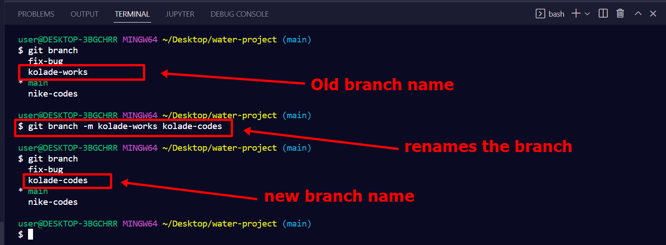

**To switch to another branch, use the `git checkout` command:**

**```**

**$ git checkout branch_name**

**```**

**To merge changes from one branch to another, use the `git merge` command:**

**```**

**$ git merge branch_name**

**```**

**Introduction to GitHub**

**GitHub is a hosting platform for Git repositories that allows you to collaborate with others on the same codebase. With GitHub, you can manage version control, track changes, collaborate with other developers, and much more.**

**Creating a Repository on GitHub**

**To start using GitHub, you need to create a repository. A repository is a storage location for project files. To create a new repository on GitHub, follow these steps:**

**1. Sign in to GitHub and click the "New repository" button on the main page.**

**2. Give the repository a name and, if needed, a brief description.**

**3. Choose whether the repository will be public or private.**

**4. Optionally, initialize the repository with a license file, .gitignore file, or README file.**

**5. Click "Create repository" to create the repository.**

**Cloning a Repository**

**To start working on an existing project on GitHub, you can clone the repository to your computer. Cloning a repository means creating a local copy of the remote repository on your computer. To clone a repository, follow these steps:**

**1. Access the repository on GitHub.**

**2. Click the "Code" button and copy the repository URL.**

**3. Open the terminal or command prompt on your computer.**

**4. Navigate to the folder where you want to clone the repository.**

**5. Type the command `git clone <repository_URL>` and press Enter.**

**6. The repository will be cloned to your computer.**

**Adding Files and Making Commits**

**Once you have cloned a repository to your computer, you can add new files or make changes to existing files. To do so, follow these steps:**

**1. Open the terminal or command prompt and navigate to the repository folder.**

**2. Use the command `git add <file_name>` to add a specific file. If you want to add all modified files, use the command `git add .`.**

**3. Use the command `git commit -m "Commit message"` to commit the added changes. The commit message should be a brief description of the changes made.**

**4. The changes are now committed to the local repository.**

**Pushing Changes to GitHub**

**After committing the changes to the local repository, you can push the changes to the remote repository on GitHub using the `git push` command. To push the changes, follow these steps:**

**1. Open the terminal or command prompt and navigate to the repository folder.**

**2. Type the command `git push origin <branch_name>` and press Enter. The default branch is usually "main".**

**3. The changes will now be sent to the remote repository on GitHub.**

**Pulling Changes from GitHub**

**If you want to get the latest changes made to the repository on GitHub, you can pull the changes using the `git pull` command. To pull the changes, follow these steps:**

**1. Open the terminal or command prompt and navigate to the repository folder.**

**2. Type the command `git pull origin <branch_name>` and press Enter. The default branch is usually "main".**

**3. The latest changes will now be downloaded and updated in the local repository.**

**These are just some of the basic commands for using GitHub. There are many other advanced commands and features that can be explored to make the most of this powerful collaboration platform.**